By Julia Burke on April 13, 2015

Farewell, Eduardo Galeano

https://www.progressive.org/news/2015/04/188088/farewell-eduardo-galeano

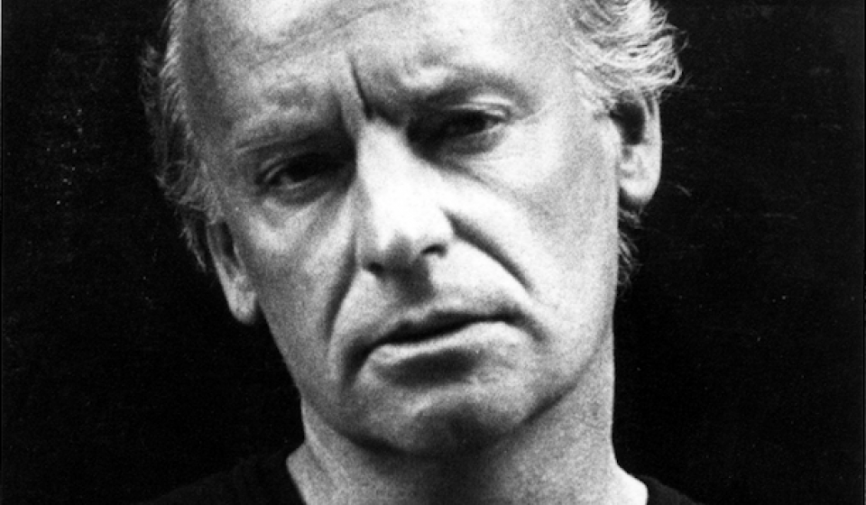
- Eduardo Galeano
Editor's Note: Today we mourn the loss of Eduardo Galeano (1940–2015), Uruguyan journalist, longtime Progressive columnist, and author, after a battle with lung cancer. Galeano was a champion of Latin American progressivism, turning his remarkable talent to civil rights, labor struggles, and pacificism. In his memory we republish this 2002 essay, "Nature is Very Tired," describing the destruction of our natural world by war and corporate power.
Who gets the water? The monkey that has the club. Unarmed creature dies of thirst. This lesson from prehistory opens the film 2001: A Space Odyssey.
For the Odyssey 2003, President Bush has announced a military budget of one billion dollars a day. The arms industry is the only investment worthy of confidence.
The ruling powers of the planet reason with bombs. They are power itself, a genetically modified power, a gigantic Frankenpower that humiliates nature: It exercises its freedom to convert air into filth and its right to leave humanity without a home; it calls these horrors errors, flattens whoever gets in its way, is deaf to all warnings, and breaks whatever it touches.
The oceans are rising and the low lands are being entombed beneath the waters. This might seem a metaphor for current economic development, but no. It’s a photograph of the world as it will be in the not-so-distant future, according to predictions of scientists consulted by the United Nations.
For more than two decades, the prophecies of ecologists were met with jokes or silence. Now scientists are saying they are right. And on June 3, none other than President Bush had to admit for the first time that disasters will happen if global warming is allowed to continue. At the same time, Bush announced that U.S. emissions of global warming gases will increase by 43 percent over the next eighteen years. After all, he presides over a nation of automobiles, more than 200 million of them. Thank god babies can’t drive. In a speech he gave late last year, Bush praised solidarity and defined it, too: “Let your kids wash the neighbor’s car.”
"Nature is very tired,” wrote the frail Spaniard Luis Alfonso de Carvallo. The year was 1695. If only he could see us now.
A large area of the map of Spain is being left without soil. The dirt is just blowing away, and sooner than later the sand will come in through the cracks in the windows. Only 15 percent of the Mediterranean’s forests are still standing. A century ago, trees covered half of Ethiopia; today, it’s a vast desert. The Brazilian Ajnazon has lost forests the size of France. At this rate, Central America will be counting its trees like a balding man counts his remaining hairs.
Erosion is forcing peasants in Mexico to leave their fields or even the country. The more degraded the planet’s lands become, the more fertilizers and pesticides will have to be used. According to the World Health Organization, these chemical “helpers” kill three million farmers a year.
Like human languages and human cultures, plants and animals are dying, as well. According to biologist Edward O. Wilson, species are disappearing at a rate of three per hour. And not only because of deforestation and pollution: Large-scale production, export agriculture, and the uniformity of consumption are annihilating diversity. Just a century ago there were more than 500 varieties of lettuce and 287 types of carrots. And 220 varieties of potato in Bolivia alone.
The forests are being stripped, the Earth is becoming a desert, poisons are filling the rivers, the ice caps and summit snows are melting. In many places the rains have simply stopped while elsewhere it pours as if the skies had cracked open. The climate of the world has gone mad.
Floods and droughts, cyclones and uncontrollable fires are becoming less and less natural, and yet, in the face of all evidence, the media insist on calling them so. And what a stunning example of black humor that the United Nations proclaimed the 1990s the International Decade for the Reduction of Natural Disasters. It was the most disastrous decade on record. Eighty-six catastrophes that left five times more dead than wars did during the same period. Almost all victims, 96 percent to be exact, died in poor countries, which experts insist on calling “developing countries.”
With devotion and enthusiasm, the South of the world copies and expands upon the worst habits of the North, but receives none of its virtues. It adopts the American religion of the automobile and its scorn for public transportation, as well as the mythology of the free market and consumer society.
But each inhabitant of the North consumes on average ten times more oil, gas, and coal. In the South, only one in a hundred people owns a car. Gluttony and fasting at the environmental café: 75 percent of global pollution comes from 25 percent of the population. And this minority does not include the 1.2 billion people who live without potable water, or the 1.1 billion who go to sleep each night hungry. It’s not “humanity” that is responsible for the devouring of natural resources, the putrefaction of the air, the Earth, and the land.
The ruling powers shrug it off. When this planet’s no longer profitable, they’ll move to another.
Beauty is beautiful if it sells; justice is just if it can be bought. The planet is being killed by lifestyles, and we are being paralyzed by machines invented to make us move faster and become more isolated from the cities that we created as places to meet.
Words are losing their meaning as the green sea and the blue sky are losing their color, tinted graciously by algae busy exhaling oxygen for three billion years.
Are the stars spying on us? They twinkle in amazement and terror—amazed at how this world so frantically devoted to its own annihilation keeps on spinning; terrified because they have already seen that this world has begun invading other bodies out in space.

