Heavy Reader: 1948

The scientist in me wants to find logical explanations for why people kill each other and do not simply share and care for one another ...
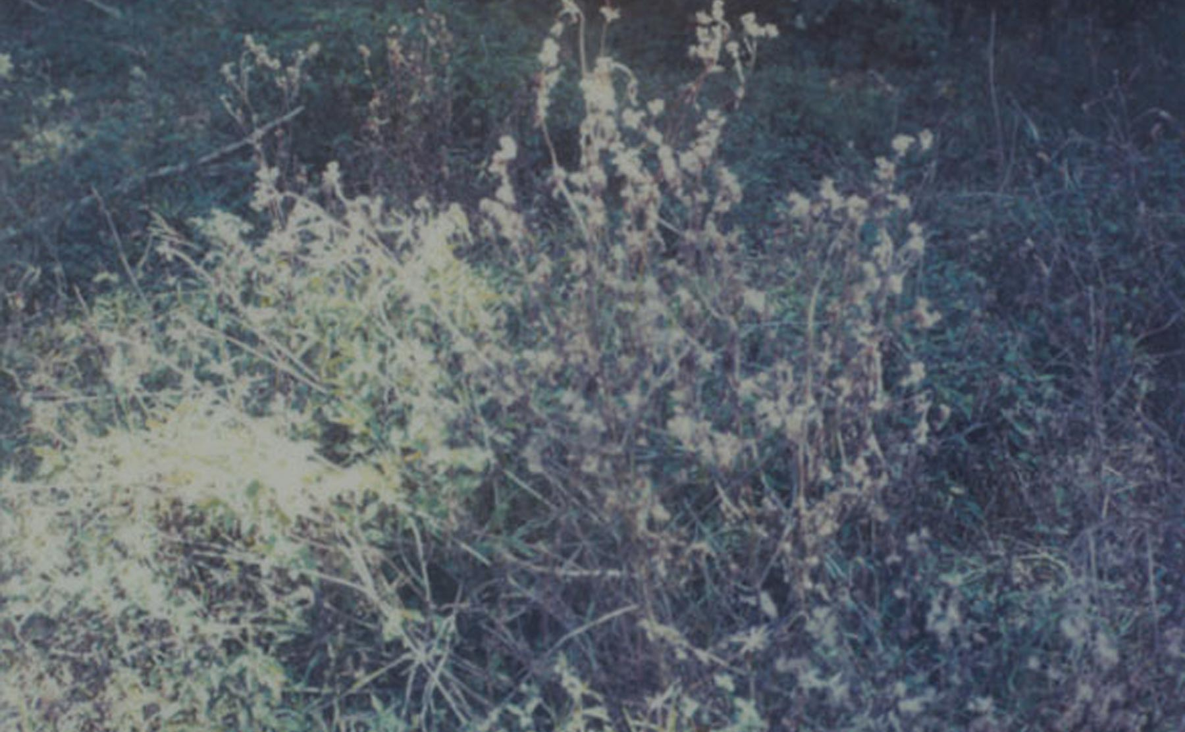
On 9 April 1948, my mother’s friend in school (both 18 at the time in teacher school in Jerusalem) chose to go back to her village of Deir Yassin. That was the last time my mother saw Hayah Balbisi who was killed in a massacre. April 9th is a day before Good Friday in our Eastern Christian Tradition. My mother, who is now 82 years old, told me not to travel and that she has been having bad dreams. I reassured her even though my own heart sends me negative signals. Deir Yassin was not the first or the largest massacre committed by Zionist forces during that era of ethnic cleansing. But it was prophetic and emblematic for us because its deliberate effect was magnified to scare the villagers (even some survivors were paraded in the streets of Jerusalem and loudspeakers told of more impending massacres). Dozens of massacres were indeed committed just in the six weeks leading up to Israel’s creation and more after. 534 villages and towns were depopulated in the bizarre 20th century attempt to transform a multicultural/multireligious Palestine into the “Jewish state of Israel.” 67 years later massacres are still being committed whether in Gaza last year or in the Palestinian refugee camp of Yarmouk. Yarmouk was home to 160,000 Palestinian refugees. It was the largest Palestinian refugee camp. It was besieged and starved. People ate grass and over 200 died of starvation. Now the fanatical forces calling themselves the Islamic State entered the camp, burned Palestinian flags and spread their terror on the remaining civilians. Necks were cut and women were raped. Different but connected perpetrators.
These and other thoughts race through the mind from 11,000 meters above the ground on my way to Paris. A flight was canceled and I had to fly to Athens, then Larnaca (Cyprus), then Paris. Larnaca airport is full of Israelis because that is the closest European airport to Lod (renamed Ben Gurion) Airport. Cyprus is used also as a transit point for the tens of thousands of Mossad agents that travel back and forth to some 140 other countries. Countless teams of assassins passed through this airport I left behind. I also think of other massacres committed in places I know well (like Kenya) or places I do not know well (like the deliberate downing of an Iranian civilian aircraft by the US and that of a German airplane by a terrorist on French soil). But then I thought, “how can I gain a bigger perspective on our lives and all these tragedies?” Here, we are tiny creatures among 7 billion “humans” that have spread around and damaged this beautiful blue planet. A planet that is small in a small inconspicuous solar system, one of billions of solar systems in this galaxy, itself a small galaxy among countless galaxies. Maybe we take ourselves too seriously, I thought. How can I help get people to know that there is enough resources to feed everyone (now over a billion go hungry). The scientist in me wants to find logical explanations for why people kill each other and do not simply share and care for one another. I try to convince myself with my own words to visitors to Palestine: lighting a candle is better than cursing the darkness, first do no harm, travel the path of your conscience even if few are doing it, etc. Maybe lack of sleep makes my mind wonder into Buddhist philosophies (joyful participation in the sorrows of this world) and to mystic philosophies (Rumi’s words come slushing around my brain). These thoughts are like shields to help us in this stark reality. The reality is that the vast majority of people on this airplane and the thousands I left behind at the airport do not know and do not care. Yarmouk, Deir Yassin, Tantura, Sabra, Shatila and others represent a heritage for us Palestinians and the few other humans who care. A country was robbed, 7 million of us are refugees or displaced people. Zionists are happy they succeeded in getting Arabs and Muslims to kill each other whether in Yemen or Syria. As the pilot announces descent to Paris, I think of the French equivalent of the Balfour Declaration (Jules Cambon’s declaration of French support for Zionism was also issued in 1917). But I know I am a minority and most people on this airplane are thinking of their next meal, of sex, of work obligations, of other thoughts. Perhaps that is how it was and how it will be. Perhaps all we can do is try our best (successfully or not) to create a ripple effect for a better more peaceful world. Perhaps that’s what I and fellow volunteers at the Palestine Museum of Natural History are trying to do. Perhaps, as the old song says: in the end only kindness matters.
It is good to be here in beautiful Paris with Eitan and Tal and all the other good people. But I already miss my mother and miss Palestine.
Mazin Qumsiyeh
https://www.adbusters.org/magazine/120/heavy-reader-1948.html

