The Long View

by Karen Phelps

7th February, 2014

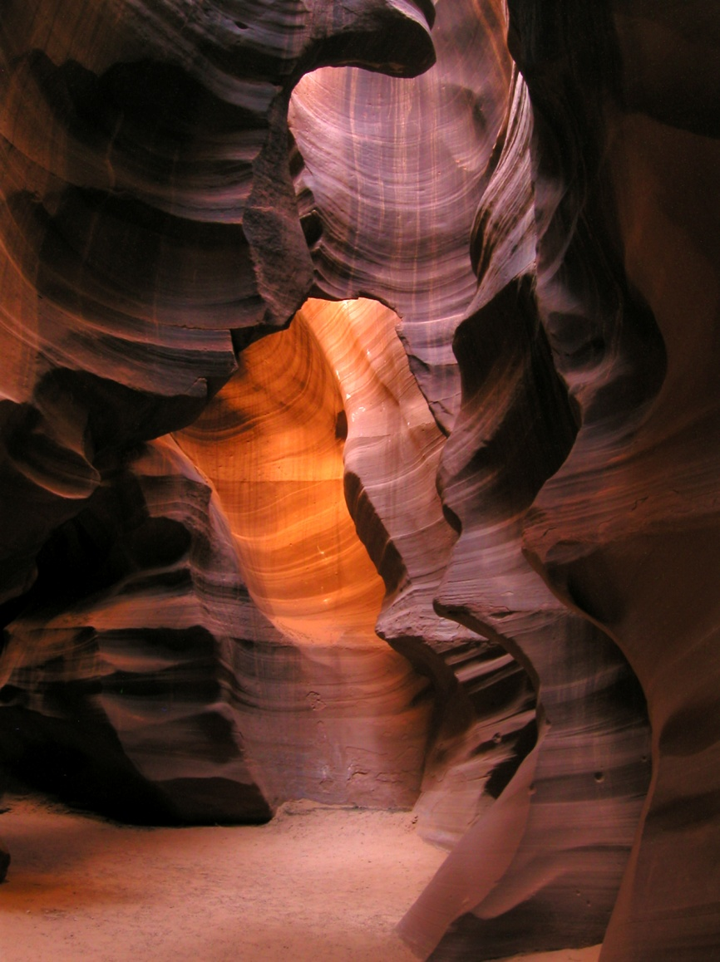

Our planet is not fragile at its own time scale, and we, pitiful latecomers in the last microsecond of our planetary year, are stewards of nothing in the long run.
— Stephen Jay Gould

A childhood in the part of New Mexico where I grew up is marked more by what is not there than what is there. There is simply no place to go.

There are two seasons — hot and windy. There are no natural sources of water like rivers or lakes that draw you in with their gravity. Trees are few and far between. It makes sense, then, that there are few animals beyond a few birds and lizards. During my last visit, a thick malaise settled around me there, and I spent some time thinking about it. It occurred to me that should the grid go down, this town would no longer exist. Poof. In three days’ time, everyone would have to leave because there would simply be no way to continue without the trucks bringing supplies, electricity pumping water from aquifers deep in the ground, and gasoline enabling cars to get from one manmade object to another.

And yet, it wasn’t until I had been away for some time that I finally realised what it offered. What I saw as wasteland was actually the bed of an extinct ocean and barrier reef. Layers of sediment show signs of life with fossils bearing witness. Deposits of salt, potash, and gypsum are what remain of the shallow sea that once lapped ashore against the ancestors of today’s Rocky Mountains. There are places where erosion and tectonic uplift display the strata of millions of years of geologic development. A school field trip included a visit to an active archaeological dig where a mammoth’s remains were painstakingly revealed with small chisels, hammers, and brushes. Nearby, spearheads and stone tools were discovered dating to about 11,000 years ago.

This was a land of clues. As sure as I once stood there, staring up into a sky full of meteor showers, so had people before and so will they after I’m gone. Species once lived here that predate humans, and something we can’t fathom may replace us. For all of our science, religion, and philosophy, our origins remain mysterious, but our distant future appears to involve being engulfed by the very sun that nurtures us as it increases in size toward red giant status. That’s right. This planet we emerged from, that sustains us, and that we bellyache about destroying, will someday no longer exist.

As Stephen Jay Gould put it in his prologue to Bully for Brontosaurus:

[N]ature is so massively indifferent to us and our suffering. Perhaps this indifference, this majesty of years in uncaring billions (before we made a belated appearance), marks her true glory… she exists neither for nor because of us, and possesses a staying power that all our nuclear arsenals cannot threaten… We should be so powerful! Nothing within our power can come close to conditions and catastrophes that the earth has often passed through and beyond… We certainly cannot wipe out bacteria… I doubt that we can wreak much permanent havoc upon insects… [b]ut we can surely eliminate our fragile selves — and our well-buffered earth might then breathe a metaphorical sigh of relief at the ultimate failure of an interesting but dangerous experiment in consciousness.

That experiment in consciousness has an interesting side effect — the ego. By its very nature, ego isn’t good at seeing the big picture. It sees me, now. It calculates, second by second, what my needs and desires are to maintain a steady state of comfort. When that comfort is challenged, it rebels until comfort is again achieved. And on it goes.

Entering nature is a surefire way to invite the ego to loosen its grip. There’s the immediate experience — bird calls, wind through branches, waves on sand, the stillness of chilled air — but if we pay attention long enough, we begin to get a sense that its timeframe and its logic are different than ours:
The soil created from the decay of organic material and aided by organisms like worms and lichens;
The lack of corners;
The rocks and stones, their cleverly disguised impermanence. They haven’t always been in that place and they will be moved again or shattered;
Today’s ‘invasive species’ become tomorrow’s natives;
What we call erosion is really the birth of a mountain elsewhere.

This is why so much of the modern ‘Green’ movement misses the mark, our ego is superimposed on everything we see. We mistake our desires for Mother Nature’s, forgetting that she indeed has none. It’s all one big experiment, with no goals and few rules.

This is not a carte blanche to wreak havoc, and Gould agrees. I hope everyone is sufficiently depressed to know that there are beaches in the world where one must dig over six inches deep to find sand free of plastic particles — plastic that will outlive us all for generations to come. Yes, Earth can absorb what we throw at it, that does not mean we should abuse the privilege. We must all conduct ourselves as we see fit in our lifetimes, and what that looks like will vary from person to person. The ego may force a selfish perspective, but it also helps us navigate an increasingly complex and demanding culture. Its pattern-making behaviour helps maintain a sense of sanity in the chaos.

But we need a wider lens. One that considers all life and respects our interconnectedness, our shared origins. You, sitting there, are the product of an unbroken chain of reproduction stretching back to the first one-celled organisms on Earth — billions of years! All your ancestors survived long enough to ensure your existence.

What is there left to do when we zoom out and understand there is no such thing as a legacy, that nothing we create will ultimately survive (even the plastics will incinerate in the sun)? The problem is, our culture asks us to cover the sounds of our inner yearnings — for connection, joy, purpose, clarity — to participate in the spectacle around us. There’s evidence that the entities in charge of the maelstrom use these human desires against us for advertising, marketing, politics, and food processing. They set the standard, such that when one questions it, you find yourself outside it and defined by its terms.

So be it. We have our lifespan, however long or short that may be, this infinitesimal slice of timeline. And yet, it is all we have. What is of value, then? Because as sure as you read this, there will be a day when you can read nothing. And if we take deathbed confessionals as our guide, it’s easy to see that no-one regrets time spent with the people they care about or sharing stories, foraging for berries, dancing too much, laughing until it hurts, skinny dipping. So how is it that we get distracted from this?

It takes practice to stay here, in the charged moment. It takes experience to know when our attentions are being drawn away to an emotional dead-end, to that place where obligation, powerlessness, and depression reside. Replace it with purpose — this is a choice! Eventually, if you listen, you will notice it. Train your inner ear as delicately as you would listening for bird calls in the forest. In our recognition of that tipping point, we can begin to give it space, to relax around it, invite our peripheral vision for a larger view, expand. We can take our place in the immense timeline of Earth, with a wide open broken-heartedness at the fragility of it all. We can set celebratory fire to all the papers asking to be pushed across our desks, chanting to the night sky and its stars, our smoke signals for a new understanding. Yes. The journey of a billion years begins now.

–

Karen Phelps is a writer living in Ashland, Oregon, USA. Various concerns include permaculture, natural human movement, evolutionary nutrition, and the benefits of a good wandering day. Blog: PaleoPeriodical.com. Twitter: @Feralization.

--------------------------------------------------------------------------------
Posted in Blog.
Bookmark the permalink.

