http://dark-mountain.net/blog/letters-to-a-young-planet/

Letters to a Young Planet

by Penny Newell

31st July, 2014
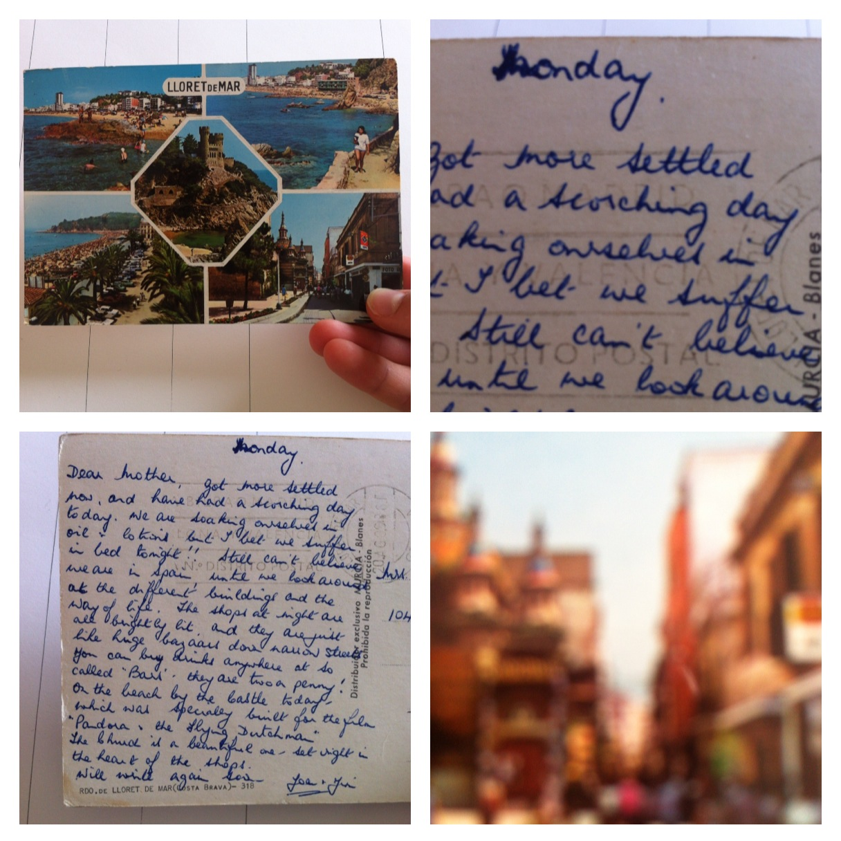Yours, letters to a young planet
Dear, it’s raining––and everybody here says: At last! Even the birds; but what would you say if you no longer had your sun . . . ? All the same, it was rain we wanted, it’s falling softly, tenderly, each drop a caress, almost a kiss.
xxxxxxxxxxxxxxxx(Rilke, Letters to Merline: 1919 – 1922)
For a long time I have been an avid reader of Rilke, though I never really understood why. This is not to say that I believe there to be reason behind our reading habits. Reading is irrational most of the time – erratic, emphatic, insane (and in this sense, reading is so much akin to the weather… erratic, emphatic, insane). This is just to say that certain writing becomes visible for distinct yet discrete reasons, seeking our attention for reasons we may only later discover. And it is this ‘seeking’ that has necessary meaning. There is so much text in the world. There is crushingly little time.
Some months ago, I started collecting found postcards, and interspersing reading these with reading Norton’s translation of Rilke’s Letters to a Young Poet; his Letters on Cézanne, and MacDonald’s translation of his Letters to Merline: 1919 – 1922. This blogpost contains an extract of a work contemplating my inability to contact the writers of these found postcards from the near past. The letters in this blogpost respond to a handful of the thousands of postcards in the collection. They attempt to tell the writers what these aesthetic objects tell me about the changing climate.
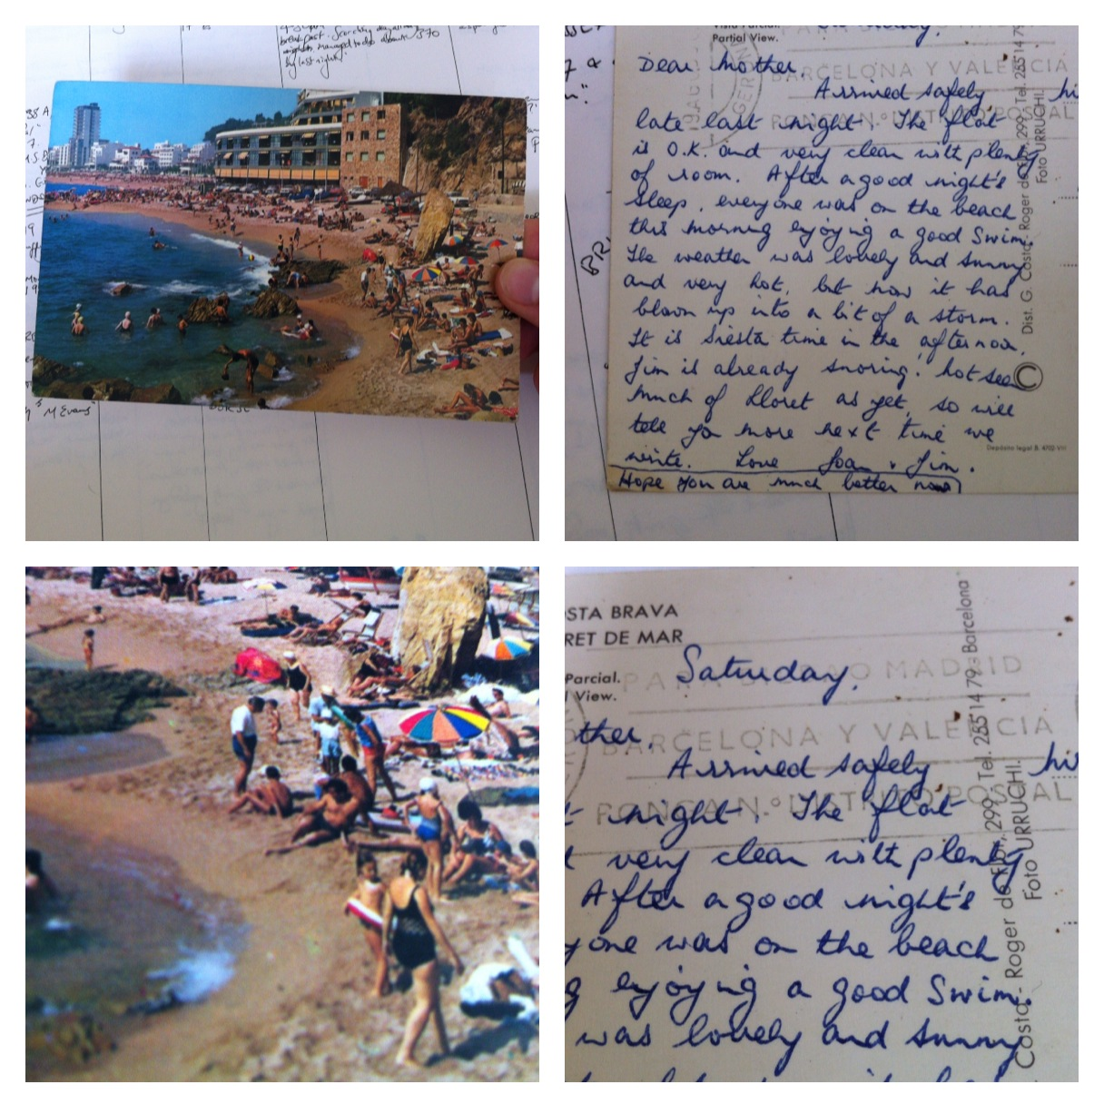Dear A.L.,
GWENT. 1976.
Your postcard was the last to arrive – just days ago – from GWENT. I want to thank you for the great confidence you have placed in me. That is all I can do. I cannot, as you say, ‘send your love to Aunt Daisy,’ nor write to you of the increasing wind, how I imagine your tan from the warm Wales sun has by now left your skin, with all your thoughts… I cannot write in this of my imagined moment of you cleanly unleashing this colourful postcard into a postbox in 1976 – how did you spend that 6½p in the post office? How did you look upon the August weather out the window, how on your browning skin? I cannot discuss these things, for fear of… Nothing touches the past so little as this remorse.
Dear Mr & Mrs H.,
TUNISIA. 14-9-2002.
Writing is difficult, and you must pardon my delay in responding to your postcard from ‘Hotel Kanta, Tunisia’ of 14-9-2002. I want to tell you that your postcard gave me an unspeakable pleasure and stirred the deepest fear within me – that ‘spectacular thunderstorm,’ not unlike the ones 11 years from your writing; floods, downpours, gales, high winds catching posts and carrying them across waterlogged fields. I want to tell you not to feel the crystal comfort of the safety of the ‘sunny a.m.’ that followed on its heels. Unspeakably alone, I leave you empty-handed; and many things must happen, in a world that feels suddenly necessary through your brief, beautiful words.
Dear D.,
TÜRKIYE. 19__
Letter by letter, I type the flight number and the time of arrival and date from the stamp and your holiday destination into Google. My search doesn’t match any documents. I do not fear you never landed at ‘Gatwick at 5.55am–’ as is invariably the way with the enchantment of disaster, had your flight fallen from the air into the ocean between Gatwick and Türkiye, that moment in the wonderful, wide fabric of our history would – laid like thread alongside an infinity of others – lack the unimportance to disappear beneath the patterning of the sea. Yet, I fear that this postcard is the only relic of you. And I must tell you that its status as an aesthetic object, its awful banality and its rupture into the inevitable critique of this response, petrifies me into a thrilling terror and hardened alarm.
Rilke writes: ‘Read as little as possible of literary criticism – such things are either partisan opinions, which have become petrified and meaningless, hardened and empty of life, or else they are just clever word-games, in which one view wins today, and tomorrow the opposite view. Works of art are of an infinite solitude, and no means of approach is so useless as criticism.’ (Letters to a Young Poet)
Letter by letter, I search the words you chose to describe the foreign weather: ‘The weather is very nice not too hot with a breeze but it gets quite cold at night.’ My search does not match any documents.
It makes ‘Suggestions’:
– Make sure that all words are spelled correctly.
– Try different keywords.
– Try more general keywords.
– Try fewer keywords.
Letter by letter, I search a correctly spelled digestion: ‘hot weather cold night’. I try to let each letter have the swell of its impression, become an embryo of reaching back through a duration into your gone moment, to square the circle of the postcard, but the message becomes obscured by the British swelter of summer 2012, instructions on ‘How to sleep in hot weather’.
Rilke: An artist stands confident in the storms of spring, unafraid that the summer may fail to come.
Me: Another stands in silence, under the ruin of the skies.
Dear C.,
LLANDUDNO. 1045AM. 23 AUG. 1979.
. . . This morning your long thoughts are with me under the awful blue of a Wednesday market sky, as I hold forth the brevity of your postcards, stealing somehow beyond itself into the immensity of your ‘Tuesday sunshine,’ akin (I think) to this one, with all your words, with all your words . . . It is a precise moment. And Rilke is with me through this. And Rilke writes to a young, aspiring poet of the powerlessness of his words to tell that poet how to become a poet – such critical asceticism, and Rilke, how you open a terminal space of disaster, where your words unleash a distant sense of what instructions on poetry might look like.
Yes, it is in the not-writing that Rilke writes of writing. Yes, it is in the venturing into privation, into elusiveness, toward the enormous namelessness that writing writes around, that Rilke somehow magically liberates words, things, emotions, even poetry of its own sad walls. C., you write home on a Tuesday in 1979 how you have ‘seen the sun though – several times. It has been sunny most of the day today.’
Only this . . . for Tuesday . . . for a thousand other moments of precision, cumulating into an imperceptible history . . .
[a brief interlude to transcribe a poem on the impossibility of exciting the distant past to change]
‘The lungs …’
The lungs
are rosette lungs
set upon
the surface of the kitchen
counter
like an elegiac joke.
Here is a future.
Here is a bag of cold
uncooked potatoes.
Here is sprouting into a witness
of a ghost you brought
about speaking around
our dancing
in the kitchen (Christmas) room.
Dear T. and L.,
ARONA. ITALIA. 6/8/81.
Perhaps if I recount the facts, this past that is so deeply taken with it-self will listen back, become another future? ‘6/8/81. Mum and I are here in Italy visiting the family and we are having a really lovely time. The weather here though is far too hot for comfort – as we are not used to it. But I am going to take advantage of it and make myself very brown.’
Yes, I wonder if in my failed effort to instruct you to re-read those signs and signal instead to each other of the coming danger, I might liberate this postcard from itself, into nameless clue.
Dear Mum,
EDINBURGH. 22-JUN 1961.
You write: ‘weather has not been too good has changed for better this morning lovely country wonderful town have made friends and shall have a nice holiday if the weather keeps fine.’
I think: Yes, in the mutiny of the strange weather of this May morning I wonder if in my failed writing I might undo the meaning of my own words through you. Your semantics remind me of the tracts that arrive for me from my own mother. And I wonder if I turn to . . .
[a brief interlude to transcribe a poem on the impossibility of reaching other humans in a confined space such as the Tube]
To the man who must be a boxer
It is a beautiful thing
to see you pass
hand over hand
fold over fold
through this evening’s paper
to wince as you clip
the scab on the knuckle
of your ring finger
to clamour at words
through inflated eyes.
Dear Joan & Jim,
LLORET DE MAR. ESPAÑA. 1968.
‘Monday
Dear Mother, got more settled now, and have had a scorching day today. We are soaking ourselves in oil + lotion but I bet we suffer in bed tonight!!’
A heat too close for comfort: I do not wonder which of you wrote this postcard, knowing the hand so well – (hiding inside, I found this postcard in my attic) – The ‘J’s of your two names familiar-curving into my own hand’s lineage, spinning out from my childhood into the poetry I never knew you had within you, Nan:
‘Still can’t believe we are in Spain until we look around at the different buildings and the way of life. The shops at night are brightly lit and they are just like huge bazaars down narrow streets.
…
‘the church is a beautiful one – set right in the heart of the shops.’
A line begins to take shape. A map begins to form. An unforeseeable map; not quite art, not quite science, beyond description-shot through with the personal, the homely, the individual, the historical moment of my writing and that of the person I can touch and speak to now, but may never address with these confiding words about the volatility of the world. This proximate distance of speaking and writing, mapped through the constellation of Nan, her postcard, and me, perfectly describes the current state of climate dialogues within our writing communities: our writing of unanswerable, unheard letters. Our dreams of impossible maps composed of poetry.
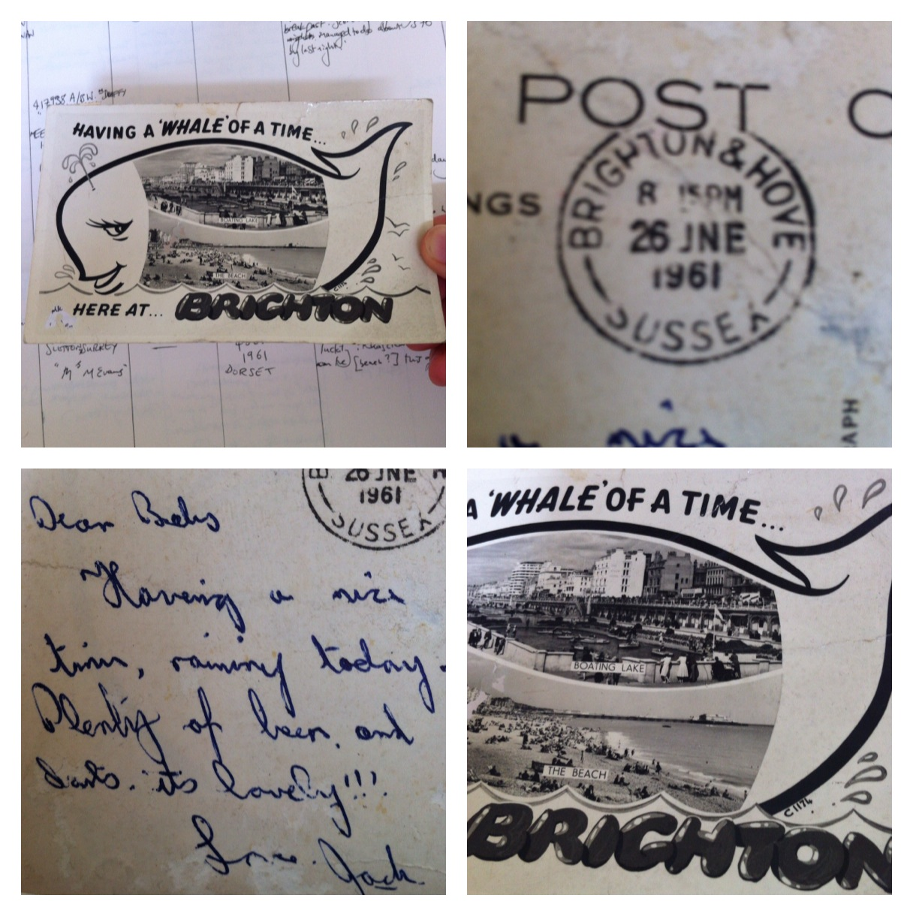
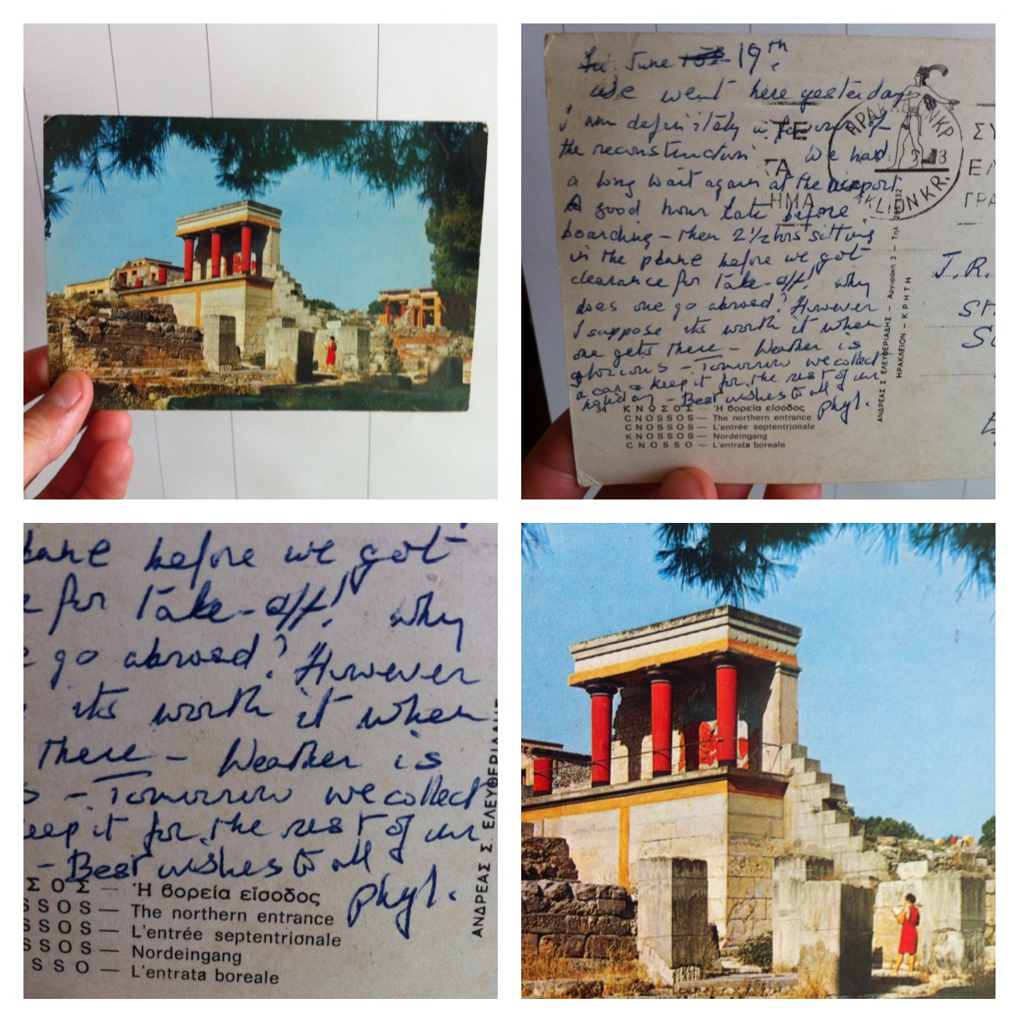Weather etc. Writing Home
There are infinite ways in which to respond to the postcards, which offer a wealth of information around individual and social relationships with the weather. And so, with support from the Royal Meteorological Society and King’s College London, we are building a public network of contributors to a new exhibition entitled Weather etc. Writing Home.
Weather etc. Writing Home is a collection of publicly donated postcards and accompanying social, artistic and scientific stories. Accumulating over a year, Weather etc. Writing Home is an invitation to search through your home to find postcards from friends, relatives and years gone by. To read and reflect on messages about the weather found in these charming postcards, and to share these to become a part of this new scientific and artistic inquiry.
At a time of rising social awareness of the changing climate, we are gathering a collection of postcards to begin reconsidering how people write and communicate a changing climate. The weather is becoming more and more of a social emergency; the climate is a political question, and climate science is grappling to answer these socio-political questions of fear, terror and amazement.
Surprisingly enough, those cast-aside postcards lying around your home have a vital scientific purpose. Climate scientists are already using unexpected tools like Twitter to crowd-source information from the general public to map the weather. And in projects like Old Weather, meteorologists are already using archives from the past to be able to reconstruct maps and models of historical weather. Weather etc. Writing Home promises to contribute new stories and maps to weather history. Scientific researchers in the field of meteorology can use your postcards to understand what the weather was doing in the past. By digitising the postcards, they can compare their weather messages to weather records, developing new understandings of what people feel, think and write about a changing climate.
We currently have over 2000 postcards in the collection. Beautiful and sometimes comical in their brevity, delightful in their stories, and profound when gathered as a collection, each one offers a unique snapshot into how people think about the weather. This growing collection is only made possible by the continued generous donation of postcards by members of the public. Please send postcards, with any accompanying stories, to the following pigeon hole:
Penny Newell
King’s College London
Department of English
Virginia Woolf Building
22 Kingsway
London
WC2B 6NR
The exhibition will take place in Spring 2015. All submitted postcards that are used will be credited, but unfortunately cannot be returned. With enquiries, please contact: penny.newell@kcl.ac.uk

